**Need some research into the locations. Are they well populated fisheries?**

Fisheries are COMMERCIAL. Instead of saying fisheries...just say lakes/ponds etc.

**According to NYSDEC**….

**Oneida Lake** is best known for its walleye and yellow perch fishery.

**Lake George** is stocked annually with landlocked salmon and has an excellent naturally reproducing population of lake trout. Brook trout can also be found at the mouth of many of the lakes tributaries. Lake George also ranks among the top five bass fishing destinations in New York State.

**Croton Reservoir,** the most popular fish species caught here are Largemouth bass, Chain pickerel, and Brown trout. (DEC doesn’t say if it’s heavily stocked or not)

**Lake Champlain** is one of the largest freshwater lakes in the country; it has 60+ species of freshwater fish. Lake Champlain is consistently ranked — on quantity, quality, and scenery — by Bassmaster as one of the top bass fisheries in the nation. Lake Champlain has a lot of territory for fish species that patrol deeper waters, most notably lake trout and landlocked salmon.

**Saratoga Lake** is an extremely fertile lake with a pH of 7.6. Its diverse structure, bottom contours and varieties of vegetation are attributes which yield a “veritable fish factory.” This top-notch fishery has been well written about in both state and national magazines for its quality and quantity of fish. Common fishes found there are largemouth and smallmouth bass, pike, walleye, crappie, perch, carp and bluegill

**Mohawk river** is also a great place because it connects with many watersheds, like the Hudson river and western sheds of the Great lakes (according to Cornell).

**What type of fishes are in these locations or in New York in general?**

NY has 165+ species of fish...some of the most common fishes in NY are bass (largemouth and smallmouth), Trout (Brook and lake), Striped bass for saltwater

Walleye and crappies are also quite popular in NY lakes (at least that’s what my research says)

**Are these parts important to fishing -> reel, lure, bait, line, spool?**

fishing reel attachment to the rod that you move to pull the fishing line in…so pretty much common sense that it’s important

In terms of bait and lure….you need to make the best judgement because there are many variables to be considered...like...light levels, water clarity, water temperature. For example...if the water is colder and the water is more murky, you want to use dead bait with a strong odor so the fishes can smell it...whereas when the water is warmer and clearer you want to use something that attracts them.

For fishing line you want to use the right line weight for the type of fish you’re planning to catch

**Is a braided line effective for freshwater fishing?**

So there are two types of fishing line, monofilament and braided. Braided has become pretty popular in the last decade and avid anglers actually recommend using the braided line 90% of the time. The one time you shouldn't use the braided line is when you’re casting into the wind. Braided line has obvious differences from nylon mono. It's much thinner (comparing similar break strengths); it has little to no stretch; it is comparatively "soft" in feel; and it is more visible.

The no-stretch trait of braid allows you to feel hits better, as they are transmitted more efficiently. This is a twin-edged sword, though, as the fish will feel the resistance from your end better as well, and is more likely to drop the bait. Thus, when fishing with braid it's wise to use lighter powered fishing rods with somewhat softer tips, so there's a bit more give.

**Is a jig effective for freshwater fishing?**

Jigs are great year round because they imitate baitfish, crawfish etc. It’s commonly-used freshwater lures equipped with weighted metal heads and a tail made of animal hair, soft plastic, feathers or rubber. Anglers sometimes add a minnow or piece of pork rind to the fishing jig's hook. Fishing jigs can be used to catch nearly every kind of freshwater and many saltwater fish.

**Worm effective bait for freshwater fishing?**

Yes :)

**What’s the difference between light/medium/heavy rods and what is a spinning rod?**

The weight of the rod basically rates how resistant the rod is to bending. Light pole for smaller fish, heavy pole for bigger fish.

Spinning rods are the rods designed to be used with spinning reels which, when mounted on the rod, will be held underneath the rod in the angler’s hand. Spinning rods are made with rod blanks that will bend or flex in all directions. Spinning rods are best suited for casting light lures and terminal tackle because of the way the line comes off the spool into guides specifically designed for spinning rods.

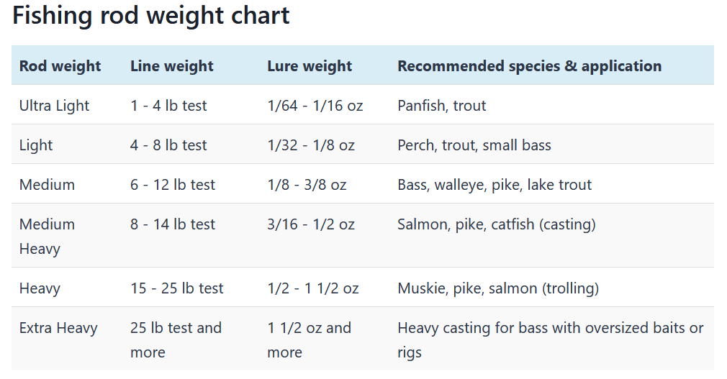

**Are shimano, daiwa good fishing brands**

Just want to clarify that these are not fishing brands...these are fishing rod + reel brands……...

Shimano and St. Croix (mentioned in the further insights) are pretty good...some of their poles and reels are consistently in the top 10 by many bloggers/fishing media outlets. Daiwa was mentioned once or two...but they are mainly known for their more affordable fishing poles

**All in all are these the proper setup for a freshwater fisherman from your research on freshwater guides?**

I think it’s pretty solid based on what I know. Obviously it doesn’t go in depth but it helps get someone started!